LAB SESSION: 01
(Array Implementation and Traversal)

- Modify the program to input values from the user instead of hardcoded values.
CODE:

#include<iostream>
using namespace std;
int main(){
int arr[5]={};
for(int i=0;i<5;i++){
cout<<"Enter Element at index ["<<i+1<<"] = ";
cin>>arr[i];
}
cout<<"-------------------------------------------------------"<<endl;
for(int i=0;i<5;i++){
cout<<"Element at index ["<<i+1<<"] is "<<arr[i]<<endl;
}
}

Output
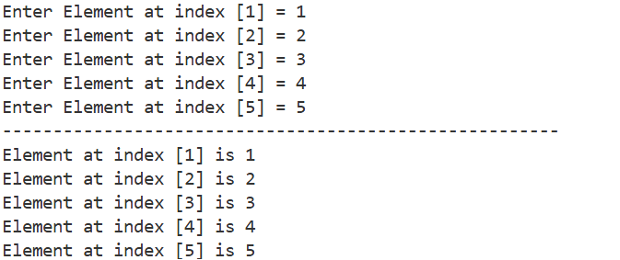

- Write a function to calculate the sum and average of all array elements.

CODE:
#include<iostream>
using namespace std;
void sum_averageOfarr(int arr[],int s){
int sum=0;
for(int i=0;i<s;i++){
sum+=arr[i];
}
cout<<"Sum of Array "<<sum<<endl;
cout<<"Average of Array "<<sum/float(s)<<endl;
}

int main(){
int arr[6]={3,6,3,6,8,3};
int size=sizeof(arr)/sizeof(arr[0]);
sum_averageOfarr(arr,size);
}

Output
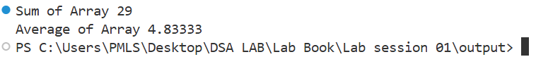

- Find the maximum and minimum values in the array.

CODE:
#include<iostream>
using namespace std;
int main(){
int arr[6]={44,22,6,1,77,4};
int max=arr[0];
int min=arr[0];
for(int i=0;i<6;i++){
if(arr[i]>max){
max=arr[i];
}
if(arr[i]<min){
min=arr[i];
}
}
cout << "Maximum element in array is: " << max << endl;
cout << "Minimum element in array is: " << min << endl;
}

OUTPUT:
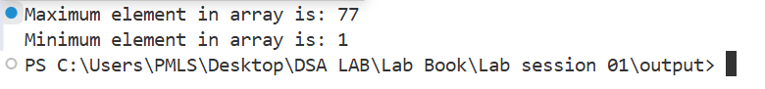

- Display the array elements in reverse order:
CODE:
#include<iostream>
using namespace std;
void printArr(int arr[],int s){
for(int i=0;i<s;i++){
cout<<arr[i]<<" ";
}
cout<<endl;
}
void reverseArr(int* arr,int s){
int start=0;
int end=s-1;
while(start<end){
swap(arr[start],arr[end]);
start++;
end--;
}
}
int main(){
int arr[5]={1,2,3,4,5};
int size=sizeof(arr)/sizeof(arr[0]);
cout<<"Array before reversing : ";
printArr(arr,size);
reverseArr(arr,size);
cout<<"Array after reversing : ";
printArr(arr,size);
}

OUTPUT:
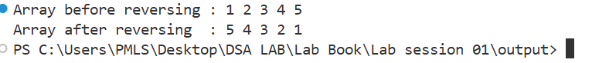
- Write a function to find the second-largest element in the array.
CODE:

#include<iostream>
using namespace std;
int main(){
int arr[8]={25,16,38,10,35,48,20,50};
int size=sizeof(arr)/sizeof(arr[0]);
int max1,max2;
if(arr[0]>=arr[1]){
max1=arr[0];
max2=arr[1];
}
else{
max2=arr[0];
max1=arr[1];
}

for(int i=2;i<size;i++){
if(arr[i]>max1){
max2=max1;
max1=arr[i];
}
else if (arr[i] > max2 && arr[i] != max1) {
max2 = arr[i];
}
}
cout<<"Second Maximum element is: "<<max2;
}

OUTPUT:

- Write a function that calculates the frequency of each unique element in the array:
CODE:
#include <iostream>
using namespace std;

void frequencyOfElements(int arr[], int n) {
bool visited[n];
for (int i = 0; i < n; i++) {
visited[i] = false;
}

cout << "Element frequencies:\n";
for (int i = 0; i < n; i++) {
if (visited[i])
continue;
int count = 1;
for (int j = i + 1; j < n; j++) {
if (arr[i] == arr[j]) {
visited[j] = true;
count++;
}
}
cout << arr[i] << " -> " << count << endl;
}
}

int main() {
int arr[] = {10, 20, 10, 30, 20, 40, 10, 30};
int size = sizeof(arr) / sizeof(arr[0]);
frequencyOfElements(arr, size);
}

OUTPUT:
